Experiment 2

**Aim:** To design Flutter UI by including common widgets.

**Theory:**

Widgets: Each element on a screen of the Flutter app is a widget. The view of the screen completely depends upon the choice and sequence of the widgets used to build the apps. The structure of the code of an app is a tree of widgets.

* Flutter Scaffold: Scaffold is a layout structure provided by Flutter that provides a framework for implementing the basic material design visual layout structure of the Flutter app.
* Flutter Container: Container is a widget that allows you to customize its appearance using properties like color, padding, margin, and more. It's a basic building block for creating layouts in Flutter.
* Flutter Row & Column: Row and Column are layout widgets used for arranging child widgets horizontally (Row) or vertically (Column).
* Flutter Text: Text widget is used to display a string of text with a single style.
* Flutter Buttons: Buttons are interactive widgets that trigger actions when tapped. Flutter provides various button widgets like RaisedButton, FlatButton, IconButton, etc.
* Flutter Icons: Icons widget is used to display Material icons.
* Flutter Images: Image widget is used to display images.
* Bottom Navigation Bar: BottomNavigationBar widget is used to provide navigation between top-level views in the app.

**The code in main.dart:**

**import 'package:flutter/material.dart';**

**void main() {**

**runApp(UdemyApp());**

**}**

**class UdemyApp extends StatelessWidget {**

**@override**

**Widget build(BuildContext context) {**

**return MaterialApp(**

**theme: ThemeData(**

**scaffoldBackgroundColor: Colors.*black*, // Set Scaffold background color to black**

**appBarTheme: AppBarTheme(**

**backgroundColor: Colors.*black*, // Set AppBar background color to black**

**),**

**),**

**home: HomePage(),**

**);**

**}**

**}**

**class HomePage extends StatefulWidget {**

**@override**

**_HomePageState createState() => _HomePageState();**

**}**

**class _HomePageState extends State<HomePage> {**

**int _selectedIndex = 0;**

**void _onItemTapped(int index) {**

**setState(() {**

**_selectedIndex = index;**

**});**

**}**

**@override**

**Widget build(BuildContext context) {**

**return Scaffold(**

**appBar: AppBar(**

**title: Text(**

**'Welcome, Aaditi Vaibhav Surve',**

**style: TextStyle(color: Colors.*white*), // Set text color to white**

**),**

**),**

**body: SingleChildScrollView(**

**child: Column(**

**crossAxisAlignment: CrossAxisAlignment.start,**

**children: [**

**Image.asset(**

**'images/home.jpg', // Path to your image asset**

**height: 440, // Adjust height as needed**

**width: MediaQuery.*of*(context).size.width, // Set width to match screen width**

**fit: BoxFit.cover, // Adjust image fit as needed**

**),**

**// Add texts below the image**

**SizedBox(height: 10),**

**Padding(**

**padding: EdgeInsets.only(left: 16.0), // Add distance from left side**

**child: Text(**

**'Learning that fits',**

**style: TextStyle(**

**color: Colors.*white*,**

**fontFamily: 'Montserrat',**

**fontSize: 18, // Adjust font size as needed**

**fontWeight: FontWeight.*bold*, // Make text bold**

**),**

**),**

**),**

**SizedBox(height: 7),**

**Padding(**

**padding: EdgeInsets.only(left: 16.0), // Add distance from left side**

**child: Text(**

**'Skills for your present (and future)',**

**style: TextStyle(color: Colors.*white*),**

**),**

**),**

**SizedBox(height: 10),**

**Padding(**

**padding: EdgeInsets.only(left: 16.0), // Add distance from left side**

**child: Text(**

**'Learning for your career?',**

**style: TextStyle(**

**color: Colors.*white*,**

**fontSize: 18, // Adjust font size as needed**

**fontWeight: FontWeight.*bold*, // Make text bold**

**),**

**),**

**),**

**SizedBox(height: 7),**

**Padding(**

**padding: EdgeInsets.only(left: 16.0), // Add distance from left side**

**child: Text(**

**'Answer two quick questions for recommendations that match your career goals.',**

**style: TextStyle(color: Colors.*white*),**

**),**

**),**

**],**

**),**

**),**

**bottomNavigationBar: BottomNavigationBar(**

**backgroundColor: Colors.*black*,**

**selectedIconTheme: IconThemeData(color: Colors.*white*),**

**selectedLabelStyle: TextStyle(color: Colors.*white*), // Set selected label color to white**

**unselectedIconTheme: IconThemeData(color: Colors.*grey*),**

**unselectedLabelStyle: TextStyle(color: Colors.*grey*), // Set unselected label color to grey**

**iconSize: 26.0,**

**selectedFontSize: 14.0,**

**unselectedFontSize: 12.0,**

**currentIndex: 0,**

**onTap: _onItemTapped,**

**type: BottomNavigationBarType.fixed,**

**items: [**

**BottomNavigationBarItem(**

**icon: Icon(Icons.*home*),**

**label: 'Featured',**

**),**

**BottomNavigationBarItem(**

**icon: Icon(Icons.*search*),**

**label: 'Search',**

**),**

**BottomNavigationBarItem(**

**icon: Icon(Icons.*star*),**

**label: 'Featured',**

**),**

**BottomNavigationBarItem(**

**icon: Icon(Icons.*school*),**

**label: 'My Learning',**

**),**

**BottomNavigationBarItem(**

**icon: Icon(Icons.*person*),**

**label: 'Profile',**

**),**

**],**

**),**

**);**

**}**

**}**

**Output:**

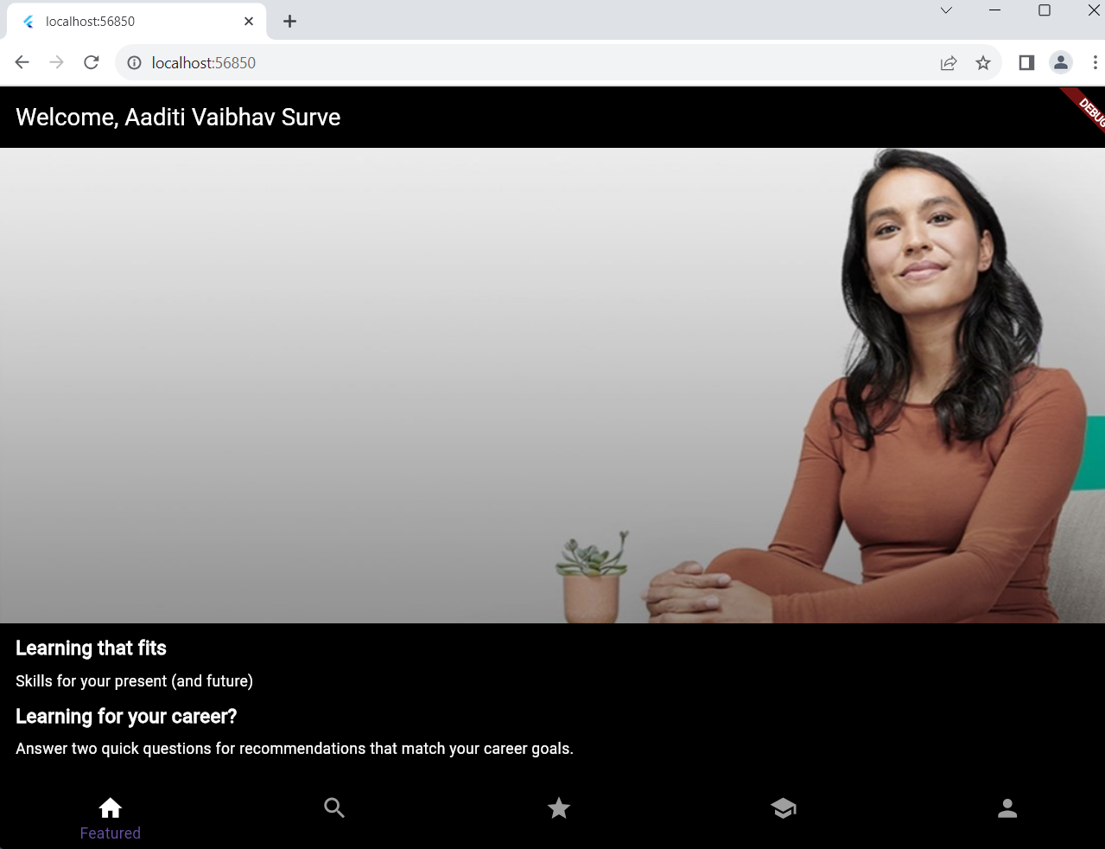

In the code, the following widgets are used:

1] MaterialApp: Provides the root widget for the Flutter application. Defines the overall theme of the application.

2] Scaffold: A layout structure widget that provides a framework for implementing the basic material design visual layout structure of the app.

3] AppBar: Represents the app bar at the top of the screen. Displays the title 'Welcome, Aaditi Vaibhav Surve' with white text color.

4] SingleChildScrollView: Enables scrolling when the content of the column exceeds the available screen space.

5] Column: A layout widget that arranges its children in a vertical array.

6] Image: Widget used to display images.

7] SizedBox: A box with a specified size. In this case, used to add spacing between widgets vertically.

8] Padding: Adds padding around its child widget to create space. Used to add left padding to the text widgets.

9] Text: Widget used to display a string of text with a single style.

10] BottomNavigationBar: Widget used to display a horizontal row of several items, typically icons or text labels, that can be selected.